**Description**

As a admin I must have ability to navigate to admin Login page.

------------------------------------------------------------------------------------------------------------------------------------------

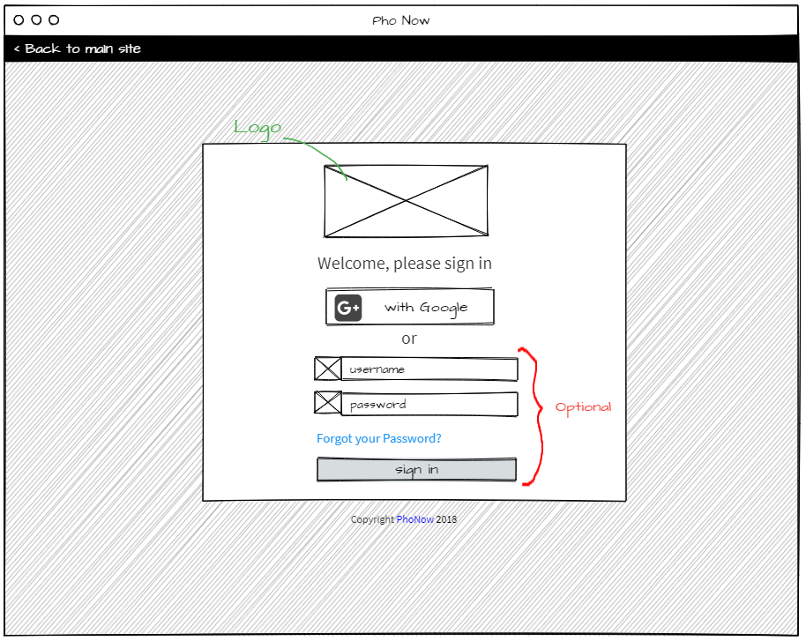

**Acceptance criteria**

* Displays Login page
* Options to login are with Google account or create new account
* Displays Sign in button.
* May display option to recover forgotten password.